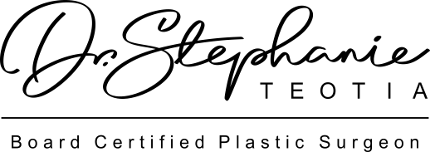

BREAST AUGMENTATION

You may shower 48 hours after surgery. Do not soak the incisions. Pat the incisions dry.

You are to wear a sports bra for compression for a total of 6 weeks after the procedure. Avoid underwire unless instructed otherwise. Place kotex pads in your sports bra the first week after surgery to absorb and drainage and to avoid the band rubbing on your incisions.

If steri-strips (tape) were placed over your incision, allow them to fall off on their own.

Sleep in a sitting or upright position the first two days after surgery to reduce swelling.

Take the pain medication as directed. While taking narcotics, take 100 mg of Colace by the mouth twice a day starting the night of surgery to prevent constipation This is an over the counter drug. Stop taking Colace for loose stools. You may take Milk of Magnesia, Miralax, Senna, or your laxative of choice as needed for constipation. Drink plenty of water.

Do not drive while using narcotic pain medicines.

Avoid aspirin or ibuprofen containing products.

Do not perform any vigorous activity or heavy lifting for two weeks. Walking is encouraged.

You will have some swelling and bruising of your breasts and surrounding tissues. This is normal. Swelling can cause the breast skin to appear shiny. You may also find a mild to severe itchy feeling of the breast. An antihistamine like Benadryl can help to alleviate itching. If the skin becomes red and hot to the touch, contact our office immediately.

Hypersensitivity of nipples or lack of sensitivity is normal and will gradually resolve over time. You may also experience a small amount of fluid or milk seeping through the nipples. If this becomes painful or excessive please notify our office.

If you had implants placed, it is normal for your chest to feel heavy as you adjust to your implants. This will subside within 2-4 weeks following surgery. Breast may look or feel quite different from on another in the days following surgery. This is normal. Although no two breasts in nature or following surgery are perfectly symmetrical, breast massage and time will produce breasts that are similar in shape, position and size. You will be taught to massage your breasts during your post-operative clinic visits. A sloshing sound or sensation is perfectly normal and will resolve within 2-4 weeks.

CALL THE OFFICE AT 214-823-9652 IMMEDIATELY FOR THE FOLLOWING:

- YOU HAVE A FEVER OVER 101.5 DEGREES.
- YOU HAVE SUDDEN INCREASE IN SWELLING OR YOU NOTICE A SIGNIFICANT SIZE DIFFERENCE BETWEEN THE BREASTS.
- YOU HAVE UNUSUALLY SEVERE PAINS.
- THERE IS REDNESS OR THICK DRAINAGE AROUND THE INCISIONS.
- YOU EXPERIENCE SHORTNESS OF BREATH OR SWELLING IN ONE LEG - CALL 911 IF THIS IS A TRUE EMERGENCY.

